**Harsh Kasliwal**

**2003085**

**C21**

**EXPERIMENT 10**

**AIM:**

Python program to demonstrate MYSQL database connectivity with python. Create a GUI based application using widgets Entry, Label, Text, Button, RadioButton, CheckButton, ListBox, Menu, Spinbox **(any five)**.

Save the details in a database and read back from file on python prompt.

**THEORY:**

**MySql DB:**

MySQL is a relational database management system based on SQL – Structured Query Language. The application is used for a wide range of purposes, including **data warehousing, e-commerce, and logging applications**. The most common use for mySQL however, is for the purpose of a web database.

We will use *mysql.connector* library to establish a connection between Python project and MySQL workbench. Db is the object created using mysql.connector.connect class which stores all the information about databases such database name, password, and table name.

**Code:**

from tkinter import *

import mysql.connector as m

conn = m.connect(user='root', password='', host='localhost', database='1.py')

cursor = conn.cursor()

def insert():

sqlformula = "insert into details(id, name, year, dept) values (%s, %s, %s, %s)"

info = (int(e0.get()), e1.get(), val.get(), lb.get(lb.curselection()))

cursor.execute(sqlformula, info)

conn.commit()

e0.delete(0, END)

e1.delete(0, END)

lb.selection_clear(0, END)

def delete():

if e0.get():

sqlformula = "delete from details where id = %s"

name = (e0.get(),)

cursor.execute(sqlformula, name)

conn.commit()

elif e1.get():

sqlformula = "delete from details where name = %s"

name = (e1.get(),)

cursor.execute(sqlformula, name)

conn.commit()

elif lb.curselection():

sqlformula = "delete from details where dept = %s"

dept = (lb.get(lb.cureselection()),)

cursor.execute(sqlformula, dept)

conn.commit()

lb.selection_clear(0, END)

else:

sqlformula = "delete from details where year = %s"

year = (val.get(),)

cursor.execute(sqlformula, year)

conn.commit()

e0.delete(0, END)

e1.delete(0, END)

lb.selection_clear(0, END)

def update():

sqlformula = "update details set year = %s, dept = %s where id = %s"

info = (val.get(), lb.get(lb.cureselection()), e0.get())

cursor.execute(sqlformula, info)

conn.commit()

e0.delete(0, END)

e1.delete(0, END)

lb.selection_clear(0, END)

def show():

cursor.execute("select * from details")

for i in cursor:

print(i)

print('*'*20, end="\n")

e0.delete(0, END)

e1.delete(0, END)

lb.selection_clear(0, END)

root = Tk()

root.geometry("300x300")

f1 = Frame(root, height = 300, width = 300)

f1.propagate(0)

f1.pack()

l0 = Label(f1, text="ID: ")

l0.place(x=10, y=10)

l1 = Label(f1, text="Name:")

l1.place(x=10, y=60)

l2 = Label(f1, text="Year: ")

l2.place(x=10, y=110)

l3 = Label(f1, text="Dept: ")

l3.place(x=10, y=170)

e0 = Entry(f1, width=10)

e0.place(x=60, y=10)

e1 = Entry(f1, width=10)

e1.place(x=60, y=60)

val = StringVar()

s1 = Spinbox(f1, values = ('SE', 'TE', 'BE'), textvariable=val, width = 10)

s1.place(x=60, y=110)

lb = Listbox(f1, height = 2, width = 20, selectmode = SINGLE)

lb.place(x=60, y=170)

list1 = ['COMP','IT','EXTC','CHEM']

for i in list1:

lb.insert(END, i)

b1=Button(f1,text="INSERT",width=7,command=insert)

b2=Button(f1,text="DELETE",width=7,command=delete)

b3=Button(f1,text="UPDATE",width=7,command=update)

b4=Button(f1,text="SHOW",width=7,command=show)

b5=Button(f1,text="EXIT",width=7,command=root.destroy)

b1.place(x=10,y=220)

b2.place(x=80,y=220)

b3.place(x=150,y=220)

b4.place(x=50,y=270)

b5.place(x=120,y=270)

root.mainloop()

**OUTPUT:**

**Filling Details:**

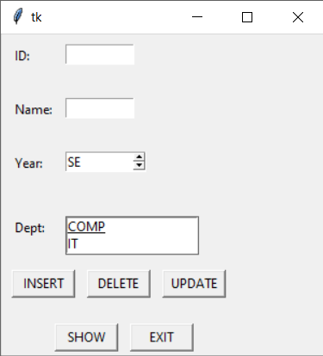

**After inserting data:**



